Patterns
As the Appointment operation in the icare is one the most important feature, it is required to make this operation secure and efficient. In doing so we have applied the Observer Patter in this feature.
Observer pattern is used when there is one-to-many relationship between objects such as if one object is modified, its dependent objects are to be notified automatically. Observer pattern falls under behavioral pattern category.
In our implementation of observer pattern, the appointment class has to inform all the users (Patient, Doctor, Nurse, and Staff) about any changes made to the appointment.

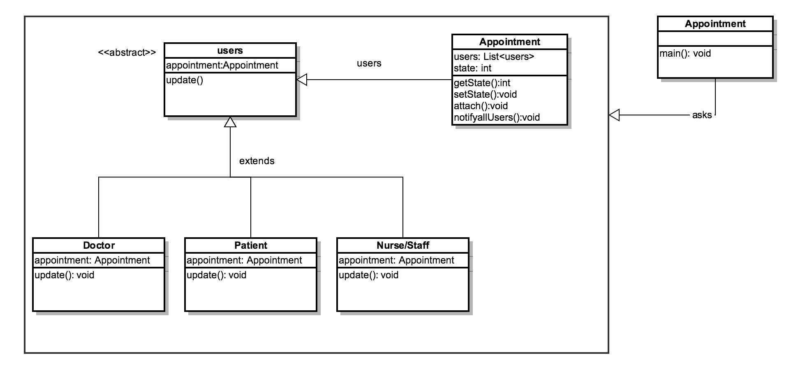
Figure 1 Observer Pattern

In here, Observer pattern is using three actor classes: Users (observer), Appointment (Subject), ObserverPatternAppointment (ObserverPatternUser). Appointment is an object having methods to attach and detach users to a client object. We have created an abstract class Users and a concrete class Subject that is extending class users. Hence whenever if we receive any update on the Appointment class the user will be notified about the change. In this way all the users while be in synchronization.
Why Observer Pattern:
- Supports the principle to strive for loosely coupled designs between Scheduling module and users that interact.
- It also allows us to send data to many other users in a very efficient manner.
- No modification is need to be done to the Appointment to add new users. Hence this provides the extensibility.

